FOCP ASSIGNMENT 1

MODULE 4
Ques 1
digit sum
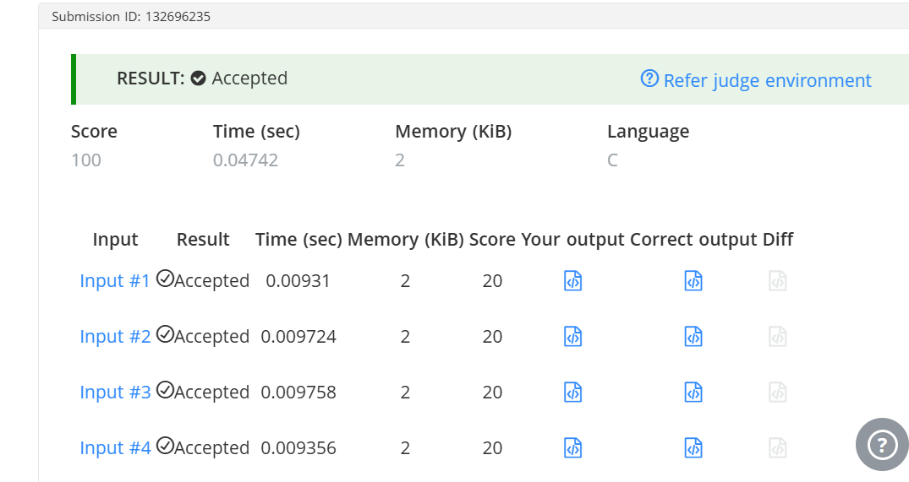
#include <stdio.h>
#include <string.h>

int main() {
int T;

scanf("%d", &T);

while (T--) {
char N[100];
scanf("%s", N);

int len = strlen(N);

int first_digit = N[0] - '0';
int last_digit = N[len - 1] - '0';

printf("%d\n", first_digit + last_digit);
}

return 0;
}

